Assignment 8: 23 Factorial Experiment using R

Andrea Lebon- 1740223

September 24, 2019

**Aim**

To analyse the following 23 factorial experiment.

**Procedure**

**Factor 1:**

**H0:** There is no significant effect of Factor 1 on crop yield.

**H1:** There is a significant effect of Factor 1 on crop yield.

**Factor 2:**

**H0:** There is no significant effect of Factor 2 on crop yield.

**H1:** There is a significant effect of Factor 2 on crop yield.

**Interaction:**

**H0:** There is no significant effect of interaction of Factor 1 and Factor 2 on crop yield.

**H1:** There is a significant effect of interaction of Factor 1 and Factor 2 on crop yield.

α = 0.05

library(readxl)

## Warning: package 'readxl' was built under R version 3.5.2

Lab8_Data_56 <- read_excel("C:/Users/Lebon/Desktop/Christ University/Statistics/DOE/Lab8_Data_56.xlsx")  
View(Lab8_Data)  
attach(Lab8_Data)  
boxplot(Yield~Factor1,data = Lab8_Data,xlab = "A",ylab = "Yield",col = c("#00AFBB","#E7B800"))

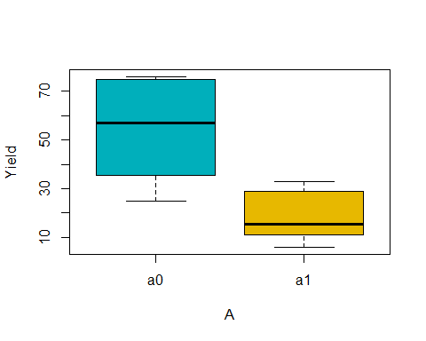

boxplot(Yield~Factor2,data = Lab8_Data,xlab = "B",ylab = "Yield",col = c("#00AFBB","#E7B800"))

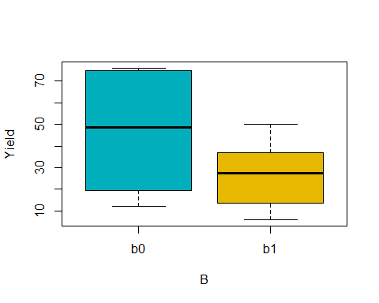

boxplot(Yield~Interaction,data = Lab8_Data,xlab = "AB",ylab = "Yield",col = c("#00AFBB","#E7B800"))

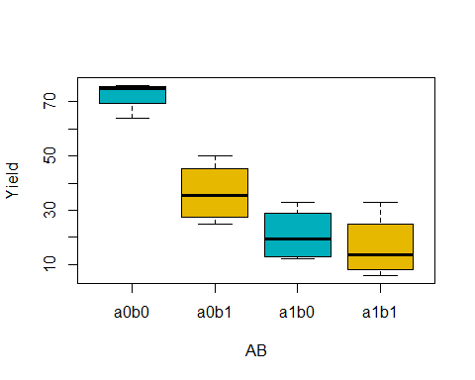

model <- aov(Yield~Factor1+Factor2+Factor1*Factor2,data = Lab8_Data)  
summary(model)

## Df Sum Sq Mean Sq F value Pr(>F)   
## Factor1 1 5112 5112 51.59 1.11e-05 ***  
## Factor2 1 1640 1640 16.55 0.00156 **   
## Factor1:Factor2 1 992 992 10.01 0.00815 **   
## Residuals 12 1189 99   
## ---  
## Signif. codes: 0 '***' 0.001 '**' 0.01 '*' 0.05 '.' 0.1 ' ' 1

**Conclusion**

Factor 1:

a0 has more variation than a1. Also, the p – value obtained (**1.11e-05)** < 0.05.   
Hence, it can be said that Factor 1 has a significant effect on crop yield.

Factor 2:

b0 has more variation than b1. Also, the p – value obtained (**0.00156)** < 0.05.   
Hence, it can be said that Factor 2 has a significant effect on crop yield.

Interaction:

a0b0 has least variation than any other whereas a0b1, a1b0, a1b1 have almost similar variation. Also, the p – value obtained (**0.00815)** > 0.05. Hence, it can be said that the interaction of Factor 1 and Factor 2 has no significant effect on crop yield.